LABORATORY EXERCISE 3

BUILDING A RESPONSIVE LOGIN & DASHBOARD SYSTEM WITH BOOTSTRAP 5 AND JAVASCRIPT

Learning Objectives
By the end of this laboratory exercise, students should be able to:
- Structure a multi-page, semantic web application using HTML5.
- Implement responsive and visually appealing layouts using the Bootstrap 5 Grid System and its core components (Navbar, Cards, Forms, Alerts, Buttons).
- Customize Bootstrap's default styling by writing custom CSS to match a unique brand identity.
- Manipulate the Document Object Model (DOM) using Vanilla JavaScript (ES6) to create dynamic user experiences.
- Simulate user authentication and state management using local Storage.
- Apply the "theme" concept by personalizing a generic dashboard for a specific business context.

Prerequisite student experiences and knowledge
Before starting this exercise, students should have:
- Completed Laboratory Exercise 2 (Enhancing HTML Structure & CSS Creativity)
- Basic understanding of HTML tags and semantic elements (header, nav, main, section, footer)
- Familiarity with CSS styling techniques including colors, fonts, and layout
- Basic knowledge of JavaScript syntax (variables, functions, conditionals, events)
- Familiarity with opening files via Live Server or localhost
- XAMPP and VS Code properly installed and configured
- Basic understanding of color schemes and color theory.

Background
In Laboratory Exercise 2, you transformed a basic HTML page into a visually appealing, well-structured webpage using semantic HTML elements and a carefully selected color scheme. You learned how CSS controls the presentation layer, including colors, fonts, spacing, and layout. While your webpage was visually engaging, it remained static; it displayed the same content to every user and did not respond to user interactions.

In real-world web development, modern websites and web applications are expected to be interactive and dynamic. They respond to user input, display personalized content, and provide seamless experiences across devices. This is where client-side scripting and front-end frameworks become essential.

JavaScript is the programming language of the web. It allows you to:
- Respond to user actions (clicks, form submissions, keyboard input)
- Dynamically update content without reloading the page
- Validate user input before sending it to a server
- Store and retrieve data locally using localStorage
- Create rich, interactive user experiences
Bootstrap 5 is a powerful front-end framework that provides:
- Pre-built CSS components (buttons, cards, forms, navigation bars)
- A responsive grid system for mobile-first design
- JavaScript plugins for interactive components (modals, dropdowns, alerts)
- Consistent, professional styling out of the box

In this exercise, you will combine these technologies to build a fully functional Login & Dashboard system. This two-page application will demonstrate:
- How to structure a multi-page web application
- How to use Bootstrap 5 for rapid, responsive development
- How to customize Bootstrap with your own CSS and color scheme
- How to use JavaScript for user authentication and dynamic content
- How to apply a unique business theme to make your dashboard personalized

Your Theme Challenge:
A generic dashboard is uninteresting and does not demonstrate creativity. You must choose a unique business context or theme for your dashboard that reflects your interests or career aspirations. This theme will influence the design, content, and data displayed on your dashboard.

Example Themes:
- E-commerce Admin Dashboard: Track orders, revenue, customers, and product performance
- Fitness Tracker Dashboard: Monitor steps, calories, workouts, and progress goals
- Student Grade Portal: View overall GPA, current courses, assignments, and grades
- Restaurant Order Manager: Track daily orders, revenue, popular menu items, and table status
- Personal Finance Tracker: Monitor income, expenses, savings, and budget categories
- Project Management Dashboard: Track project status, tasks, deadlines, and team members
- Healthcare Patient Dashboard: Monitor patient appointments, medications, and vital signs
- Travel Planner Dashboard: View upcoming trips, flight status, destinations, and budgets

Materials/Resources
- Personal Computer with Internet Access (Windows, macOS, or Linux).
- XAMPP Installer (downloaded from apachefriends.org).
- Visual Studio Code (downloaded from code.visualstudio.com).
- Web Browser (Google Chrome is recommended).
- Github (https://github.com/)
- Color Scheme Resources (for reference):
  - Coolors.co Color palette generator
  - Adobe Color Color wheel and theme creator
  - ColorHunt Curated color palettes
THEORY / CONCEPTS
Bootstrap 5 Framework
Bootstrap is a free, open-source front-end framework that provides a collection of CSS and JavaScript components for building responsive websites quickly. It was originally developed by Twitter and is now one of the most widely used frameworks in web development.

Key Bootstrap 5 Features
Feature | Description | Example Usage
Grid System | 12-column responsive layout system | <div class="row"> with <div class="col-md-4">
Components | Pre-built UI elements | Navbar, Cards, Forms, Buttons, Alerts, Modals
Utilities | Helper classes for spacing, typography, colors | d-flex, text-center, mb-3, mt-4
Responsive Breakpoints | Mobile-first design with breakpoints | sm, md, lg, xl, xxl
JavaScript Plugins | Interactive components | Dropdowns, Collapse, Carousel, Modal

Bootstrap 5 Grid System
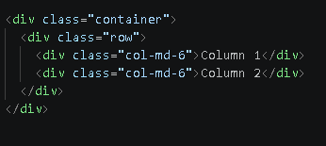
The Bootstrap grid system uses a series of containers, rows, and columns to layout and align content. It is built with flexbox and is fully responsive.

Client-Side Scripting with JavaScript
JavaScript is a high-level, interpreted programming language that enables interactive web pages. It is an essential part of web applications, providing dynamic functionality on the client side.
Concept | Description | Example
Variables | Containers for storing data | let username = "admin";
Functions | Reusable blocks of code | function checkLogin() { ... }
Event Listeners | Respond to user actions | button.addEventListener('click', doSomething);
DOM Manipulation | Changing HTML content dynamically | document.getElementById('greeting').innerHTML = "Hello!";
localStorage | Store data in the browser | localStorage.setItem('key', 'value');
Conditionals | Execute code based on conditions | if (username === 'admin') { ... }

Document Object Model (DOM)
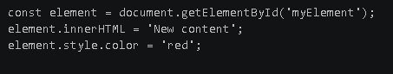
The Document Object Model (DOM) is a programming interface for web documents. It represents the page so that programs can change the document structure, style, and content. The DOM represents the document as a tree of objects.

Web Storage API: localStorage
The Web Storage API provides mechanisms for storing key-value pairs in the browser. localStorage stores data with no expiration date and persists even after the browser is closed.

Common localStorage Methods
Method | Description | Example
setItem() | Store a key-value pair | localStorage.setItem('name', 'John');
getItem() | Retrieve a value by key | let name = localStorage.getItem('name');
removeItem() | Remove a key-value pair | localStorage.removeItem('name');
clear() | Remove all stored data | localStorage.clear();

Bootstrap Customization with CSS
Bootstrap can be customized by overriding its default variables and styles. This allows you to maintain consistency with your brand or theme.
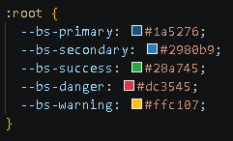
CSS Variable Overrides
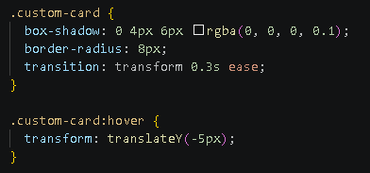
Custom CSS Classes
Color Theory and Scheme Selection
A well-chosen color scheme creates visual hierarchy, establishes brand identity, improves readability, and makes websites look professional.

Color Harmony Types (Review from Lab 2):
- Monochromatic: Variations of one color (different shades and tints)
- Complementary: Two colors opposite on the color wheel
- Analogous: Three colors adjacent on the color wheel
- Triadic: Three colors equally spaced on the color wheel

Color Roles in a Dashboard
Color Role | Purpose | Example Usage
Primary | Brand color for headers, navigation, buttons | Navbar background, main buttons
Secondary | Supporting color for accents, borders | Input focus, link colors
Background | Light/neutral color for page background | Page background, card backgrounds
Text | Dark/readable color for main text | Body text, headings
Accent | Bold color for emphasis and call-to-action elements | Alert messages, important numbers
Success | Green for positive indicators | Profit numbers, completion status
Danger | Red for warnings or negative indicators | Loss numbers, alerts

Example Color Scheme (Emerald Theme)
Color Name | Hex Code | Usage
Primary | #0d5c3e | Headers, navigation, primary buttons
Secondary | #1a936f | Accents, links, secondary buttons
Background | #f0f7f4 | Page background
Text | #1a2e24 | Main text, headings
Accent | #f3a712 | Highlights, important numbers
Light Accent | #d4ece4 | Section backgrounds, cards

Laboratory Activity
Part 1: Selecting Your Color Scheme and Theme
Before writing any code, you must select a color scheme and business theme that will define the visual identity of your dashboard.
Step 1: Choose Your Business Theme
Select one unique business context from the list below or propose your own (instructor approval required):
- E-commerce Admin Dashboard
- Fitness Tracker Dashboard
- Student Portal
- Restaurant Management

Step 2: Select Your Color Scheme
- Open your web browser and visit one of the color palette websites:
- Coolors.co
- Adobe Color
- ColorHunt

- Browse through existing palettes or generate a new one.
- Select or create a color scheme with 4-6 colors that work harmoniously together and match your chosen theme.
- Write down or copy the color codes (hex values) of your chosen colors.
- Example Color Scheme (Emerald Theme for Fitness Tracker):
Color Name | Hex Code | Usage
Primary | #0d5c3e | Headers, navigation, primary buttons
Secondary | #1a936f | Accents, links, secondary buttons
Background | #f0f7f4 | Page background
Text | #1a2e24 | Main text
Accent | #f3a712 | Highlights, important numbers
Light Accent | #d4ece4 | Section backgrounds, cards

Part 2: Project Setup and HTML Skeleton
Step 1: Create Project Folder Structure
- Open Visual Studio Code.
- Navigate to your lab folder (where you stored Lab 1 and Lab 2).
- Create a new folder named lab3_YourStudentID (e.g., lab3_20251234).
- Inside this new folder, create the following structure:
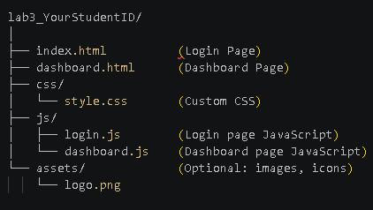

Step 2: Create the Login Page (index.html)
- Create a new file named index.html in your lab3_YourStudentID folder.
- Type ! and press Tab to generate the HTML5 boilerplate.
- In the <head> section, link the Bootstrap 5 CSS CDN and your custom CSS file.
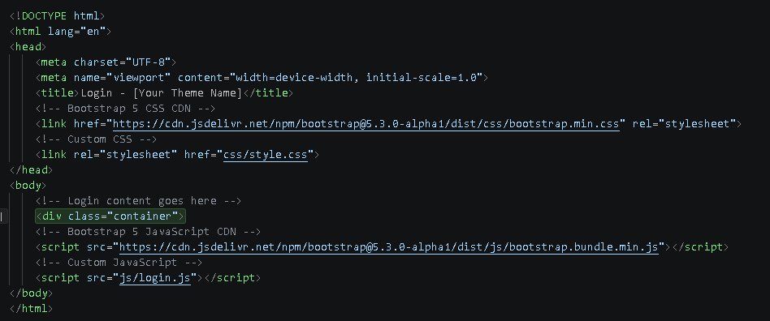
Step 3: Create Project Folder Structure
- Create a new file named dashboard.html in your lab3_YourStudentID folder.
- Add the same Bootstrap CDN links and custom CSS file in the <head> section.
- Add the Bootstrap JS and your custom dashboard.js script before the closing </body> tag.

Part 3: Building the Login Page (index.html)
Step 1: Create the Login Card Container
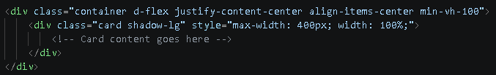
Inside the <body> tag of index.html, create a full-page centered container:

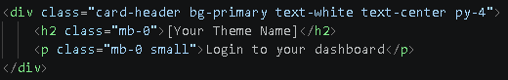
Step 2: Add Card Header with Logo/Branding

Step 3: Add the Login Form
Inside the card body, create a form with the following fields:
Note: The type="button" on the login button prevents the page from reloading, allowing JavaScript to handle the login process.

Step 4: Customize the Login Page for Your Theme
- Replace [Your Theme Name] with your chosen business theme
- Customize the background color or add a branded logo area using custom CSS
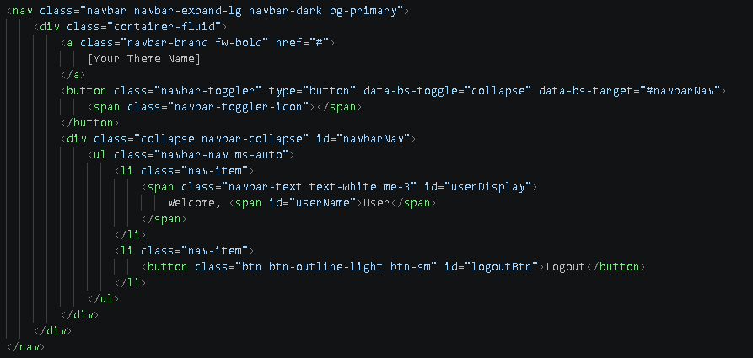
- Consider adding a background image or gradient to the page body

Part 4: Building the Dashboard Page (dashboard.html)
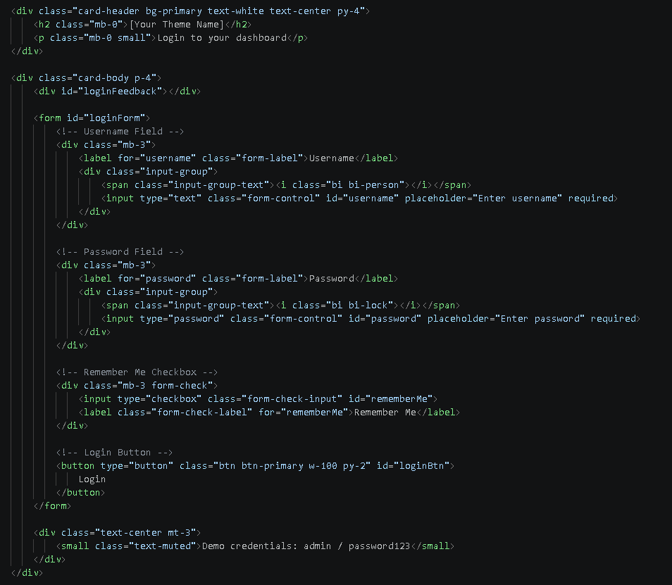
Step 1: Create the Navigation Bar
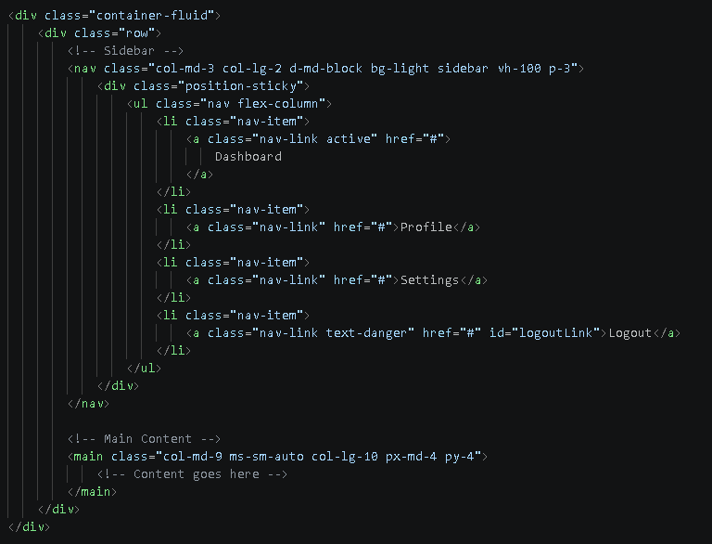
Step 2: Create the Sidebar and Main Content Layout

Step 3: Add Main Content Components
Inside the <main> section, add:

Welcome Greeting

Statistic Cards
Create 4 statistic cards that represent key metrics for your theme.
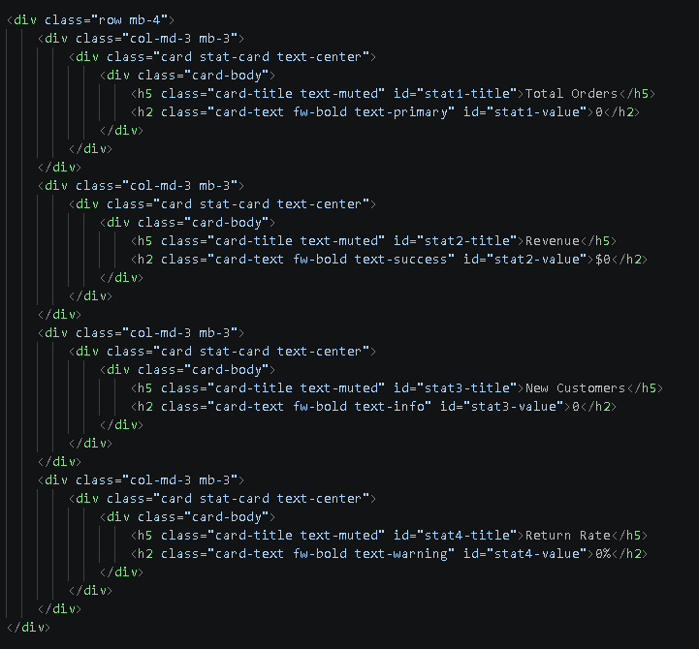

Recent Activity Table
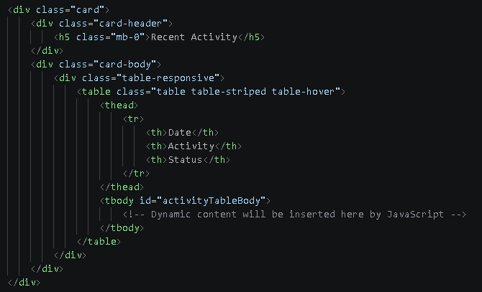
Create 4 statistic cards that represent key metrics for your theme.
Step 4: Customize for Your Theme
Replace placeholder text with theme-specific content:
- For E-commerce: Orders, Revenue, Customers, Return Rate
- For Fitness Tracker: Steps, Calories, Workouts, Heart Rate
- For Student Portal: GPA, Courses, Assignments, Attendance
- For Restaurant Management: Orders, Revenue, Tables, Popular Items
Part 5: JavaScript Interactivity and Logic
Step 1: Create the Login Script (js/login.js)
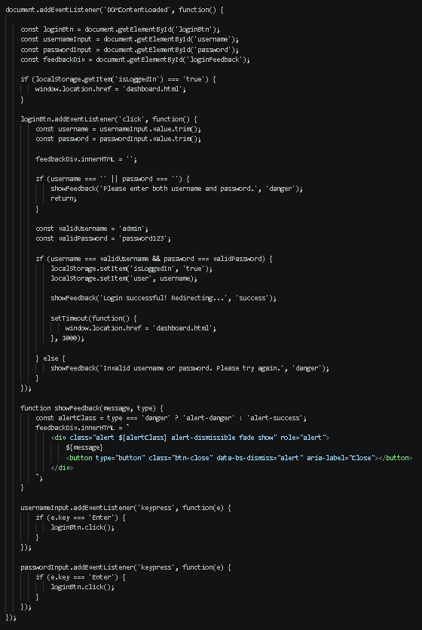
Create a new file named login.js in the js folder:


Step 2: Create the Dashboard Script (js/dashboard.js)
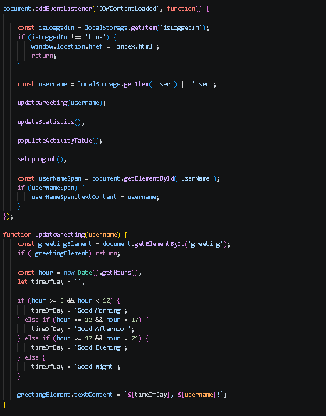
Create a new file named dashboard.js in the js folder:
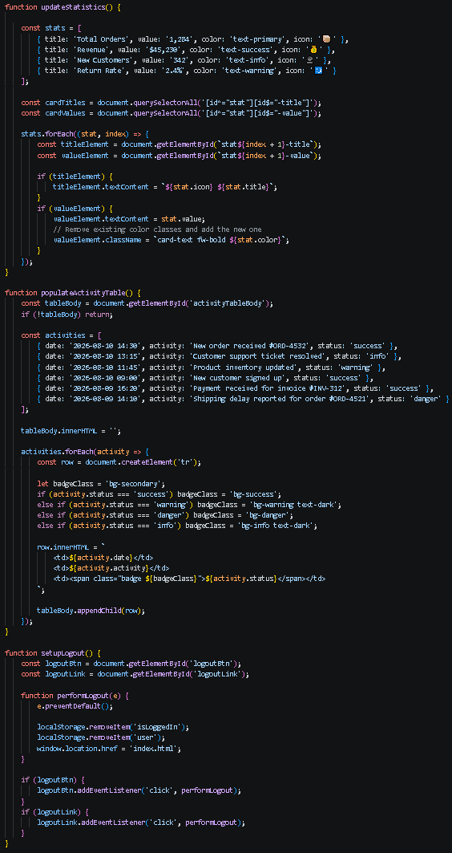
Step 3: Customize the JavaScript for Your Theme
- Modify the stats array in updateStatistics() to reflect your chosen theme
- Update the activities array in populateActivityTable() with theme-appropriate entries
- Ensure the stat card IDs in your HTML match the JavaScript (stat1-title, stat1-value, etc.)

Part 6: Custom CSS Styling and Theme Implementation
Step 1: Create the CSS File (css/style.css)
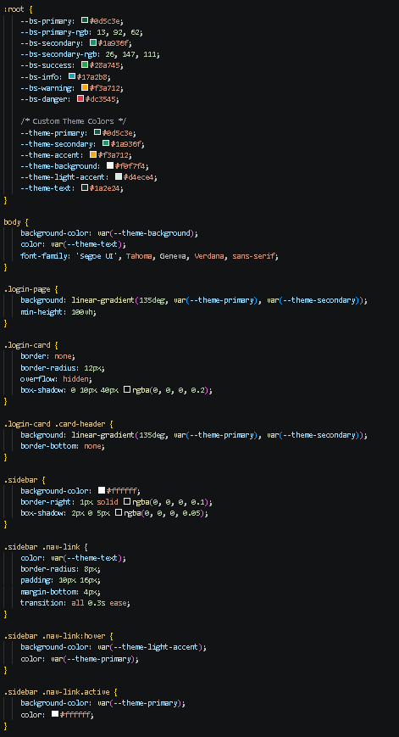
Create a new file named style.css in the css folder:
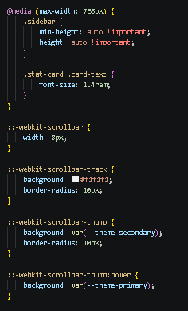
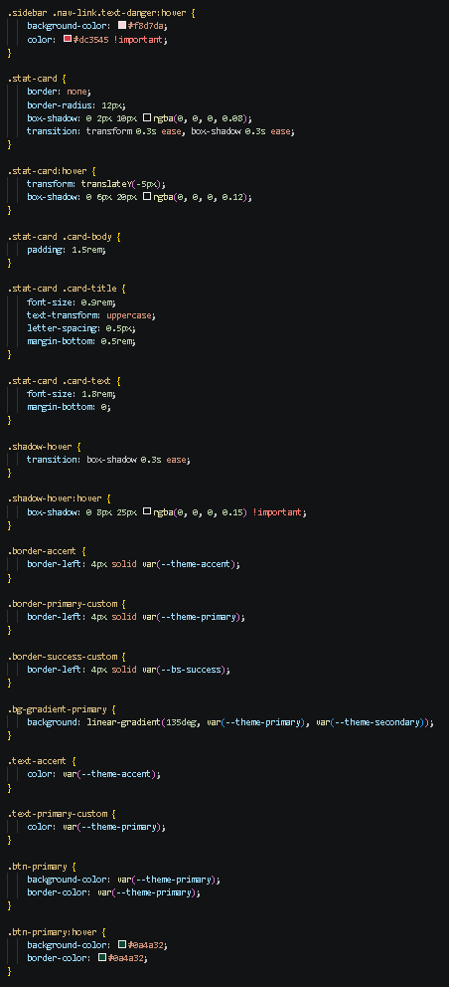
Step 2: Customize the CSS for Your Theme
- Replace the placeholder color hex values with your chosen color scheme
- Replace [Your Theme Name] with your selected business theme
- Modify the gradient colors to match your theme
- Add any additional custom styles to enhance your theme
Step 3: Apply Custom Classes to Your HTML
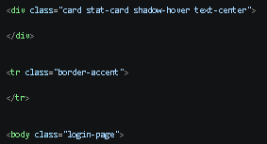
Add the custom classes you created in CSS to elements in your HTML:
Step 1: Create the CSS File (css/style.css)
Step 1: Create the CSS File (css/style.css)
Step 1: Create the CSS File (css/style.css)

Part 7: Push to GitHub
Method 1: Using Live Server
- In VS Code, right-click on your index.html file.
- Select "Open with Live Server".
- Your browser will open with a live preview that auto-refreshes when you save changes.
Method 2: Using XAMPP
- Ensure Apache is running in XAMPP Control Panel.
- Copy your lab3_YourStudentID folder to the htdocs directory.
- Open your web browser and navigate to:
  - http://localhost/lab3_YourStudentID/
  - (If using port 8080: http://localhost:8080/lab3_YourStudentID/)
- Verify that your pages load correctly with all styles applied.

Testing Checklist:
- Login page loads correctly with Bootstrap styling
- Login form accepts demo credentials: admin / password123
- Invalid credentials display an error alert
- Successful login redirects to dashboard.html
- Dashboard page displays the user's name
- Greeting changes based on time of day
- Statistic cards display theme-appropriate data
- Activity table is populated with sample data
- Logout button/links clear session and redirect to login
- Trying to access dashboard.html without logging in redirects to login
- Layout is responsive on mobile, tablet, and desktop

Part 5: Push to GitHub
- Open your GitHub repository (created in Laboratory Exercise 1).
- Add your lab3_YourStudentID folder to the repository.
- Commit and push your changes with a meaningful commit message:
  - Example: "Added Laboratory Exercise 3: Login & Dashboard System with Bootstrap 5"
- Take a screenshot of your GitHub repository showing the new files.

Output / Results
Take a screenshot of the following outputs and paste them into your lab report document:
- Screenshot 1: VS Code editor showing your complete index.html code
- Screenshot 2: VS Code editor showing your complete dashboard.html code
- Screenshot 3: VS Code editor showing your login.js and dashboard.js code
- Screenshot 4: VS Code editor showing your style.css code with your color scheme
- Screenshot 5: Your web browser displaying the Login page with URL visible
- Screenshot 6: Your web browser displaying the Dashboard page with URL visible
- Screenshot 7: Your web browser showing the responsive layout on mobile (use Chrome DevTools)
- Screenshot 8: Your GitHub repository showing the history of commits and the new lab3_YourStudentID folder
- Screenshot 9: Your color palette/color scheme (including hex codes) from Part 1

Submission Guidelines
- Name the file as: Lab3_YourStudentId_YourLastName.pdf
- Submit the file to your instructor via the Learning Management System (LMS) provided before the start of the next laboratory session.
- Required Format: Include all screenshots from the Output/Results section in your PDF report.
- Questionnaire: Answer all questions in the Questions section below in your report.
- Conclusion: Write a brief conclusion summarizing what you learned in this laboratory exercise.

QUESTIONS:
- In Laboratory Exercise 2, you created a static webpage using only HTML and CSS. In this exercise (Lab 3), you added JavaScript to create dynamic functionality. Compare the two approaches by answering the following:
  - What is the main difference between a static webpage (Lab 2) and a dynamic webpage (Lab 3)?
  - Explain how you used JavaScript to make your dashboard dynamic. Provide at least two specific examples from your code (e.g., the time-based greeting, the stat cards update, or the activity table).
  - In Lab 2, you used semantic HTML elements (<header>, <nav>, <main>, <section>, <footer>). How did you apply these same semantic elements in your Lab 3 dashboard? Give specific examples of where you used them.
Answer:
a. Main Difference
Lab 2 Static Website: The webpage shows the same content every time. To change it, you need to edit the HTML code.
Lab 3 Dynamic Website: The webpage uses JavaScript to change its content and make it more interactive.

b. How JavaScript Made the Dashboard Dynamic
Time-based Greeting: JavaScript checks the current time and shows "Good Morning" or "Good Evening" depending on the time.
Activity Table: JavaScript gets the data from an array and adds it to the table automatically.

c. Semantic Elements Applied
<nav> was used twice to mark the top navigation bar and the side menu area.

<main> was placed around the core content like greetings, stat cards, and tables to separate it from the navigation links.

- In both Lab 2 and Lab 3, you selected and applied a color scheme to your web pages.
  - Describe the color scheme you selected for your dashboard. What type of color harmony did you use (monochromatic, complementary, analogous, or triadic)? List your colors with their hex codes and explain why you chose this particular scheme for your chosen business theme.
  - In Lab 2, you wrote custom CSS from scratch to style your webpage. In Lab 3, you used Bootstrap and then overrode its default styles. Explain the difference between these two approaches. What are the advantages of using a framework like Bootstrap compared to writing all CSS from scratch?
  - Provide at least three examples of CSS properties you used in Lab 3 that you also used in Lab 2 (e.g., background-color, padding, margin, border-radius, box-shadow). How did you apply them differently when customizing Bootstrap?
Answer:
a. Color Scheme & Harmony
The dashboard uses a monochromatic-leaning scheme focused on emerald green for a clean, professional financial feel:

- Primary (#10b981) - Buttons and active elements
- Secondary (#059669) - Supporting green gradients
- Background (#0f172a) - Dark theme page backdrop
- Surface (#1e293b) - Card background panels
- Text (#e2e8f0) - Main readable body text
- Accent (#fbbf24) - Highlighting key numeric data

b. Custom CSS vs. Bootstrap Overrides
Lab 2 involved manually coding all styles and layouts. In Lab 3, we utilized the pre-defined Bootstrap classes, with custom CSS used only for minor adjustments. This approach is faster, more responsive on mobile devices, and ensures that tested layout elements are employed.

c. CSS Properties Applied Differently
Border radius: Used in custom components for Lab 2 but applied directly to Bootstrap’s .card classes in Lab 3 to smooth out corners.

Box shadow: Added over the base styling by Bootstrap in .stat-card components to give a more contemporary look.

Background color: Defined by hard-coded values in Lab 2 but using CSS variables such as var(--theme-surface) in Lab 3.

- This exercise introduced you to client-side scripting using JavaScript.
  - Explain the purpose of the localStorage object in your login system. How does it help simulate user authentication between the login page and the dashboard page? Provide specific code examples from your login.js or dashboard.js files.
  - What is an event listener in JavaScript? Identify two different event listeners you used in your project. Explain what each one does and why it improves user experience.
  - Client-side scripting is described as programs that are executed on the client-side in response to user actions. Explain how your JavaScript code demonstrates this concept. How does your code respond to user actions to create a more interactive experience compared to the static page from Lab 2?
Answer:
a. Purpose of localStorage
The concept of localStorage allows the browser to store login statuses locally without requiring a complicated backend database system. Once the user logs in, the script uses localStorage.setItem("isLoggedIn", "true"). This is verified by the main dashboard using localStorage.getItem('isLoggedIn').

b. Event Listeners
loginBtn.addEventListener('click', ...) checks credentials only when the user clicks submit, giving immediate error feedback without refreshing.

usernameInput.addEventListener('keypress', ...) lets users submit forms by hitting Enter, making sign-in smoother.

c. Client-Side Scripting in Action
Everything written in JavaScript is executed in the browser of the user itself. For instance, entering wrong credentials will immediately invoke the function showFeedback(), which will display a warning in red, without having to wait for any sort of response from the server.

Output / Results
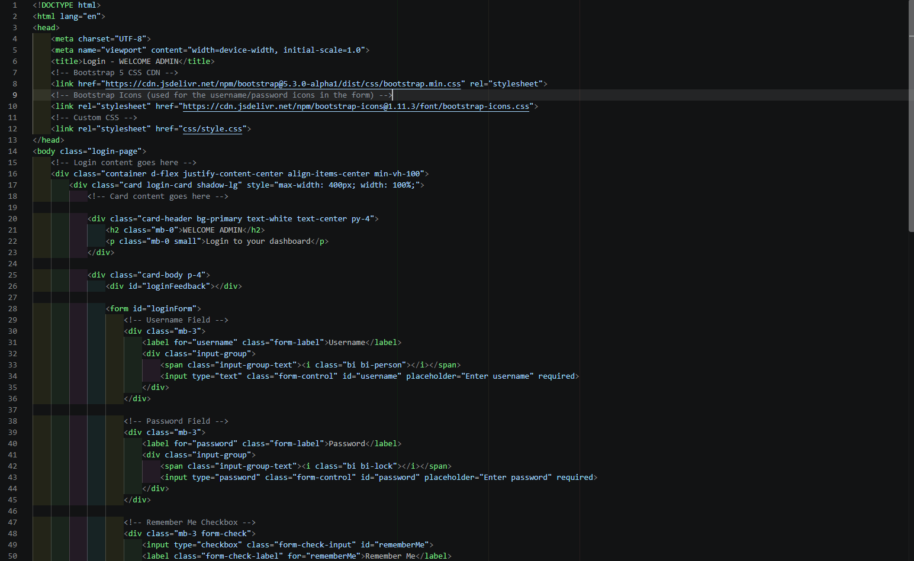
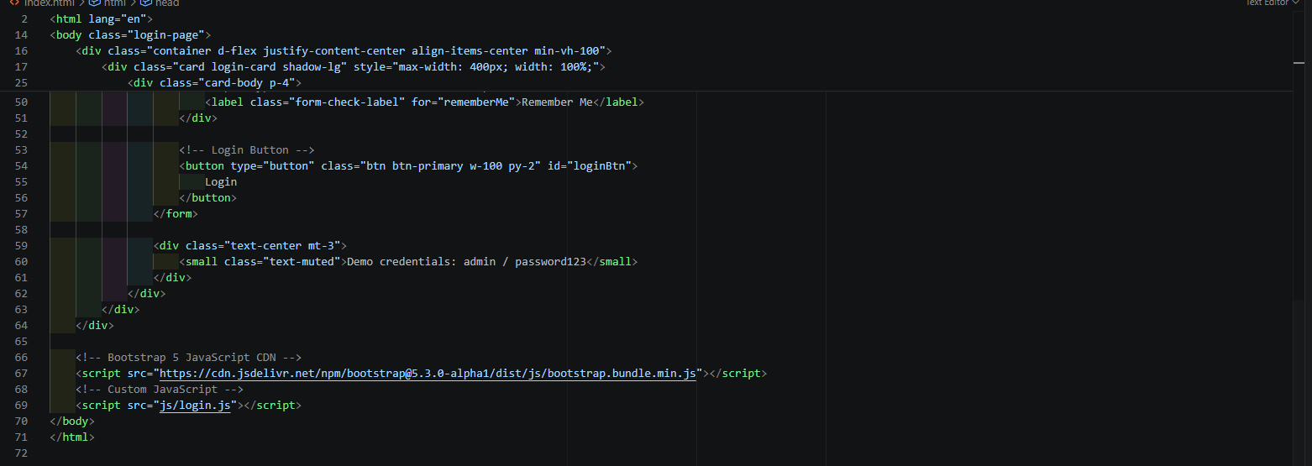

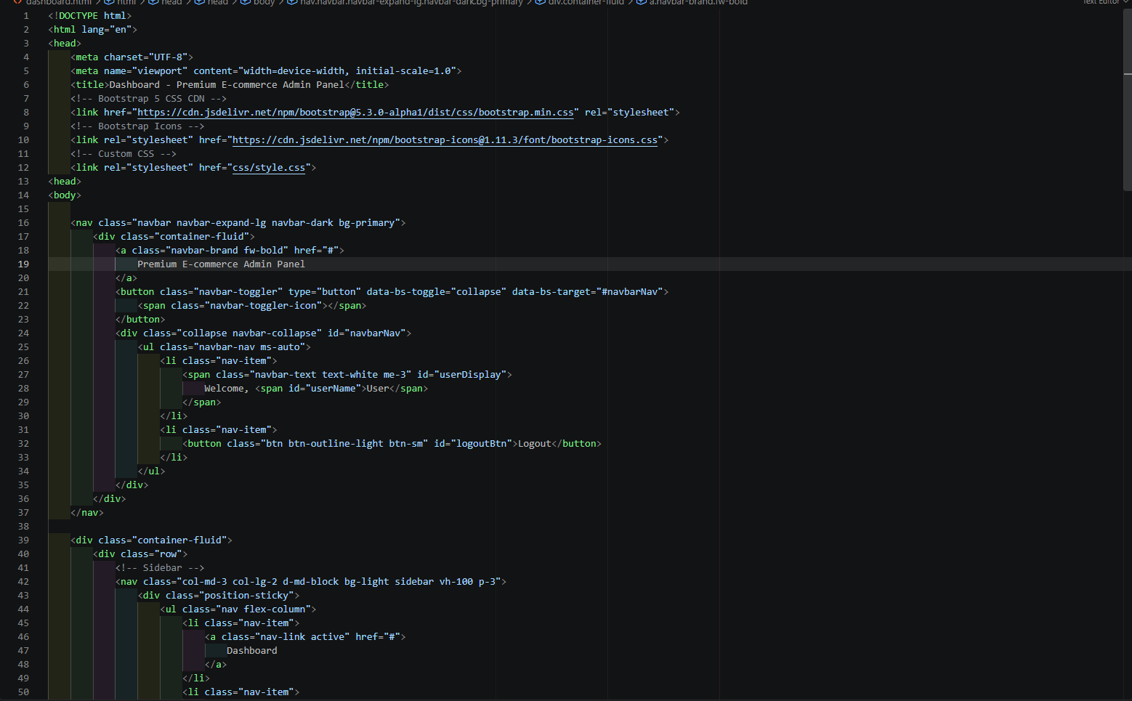
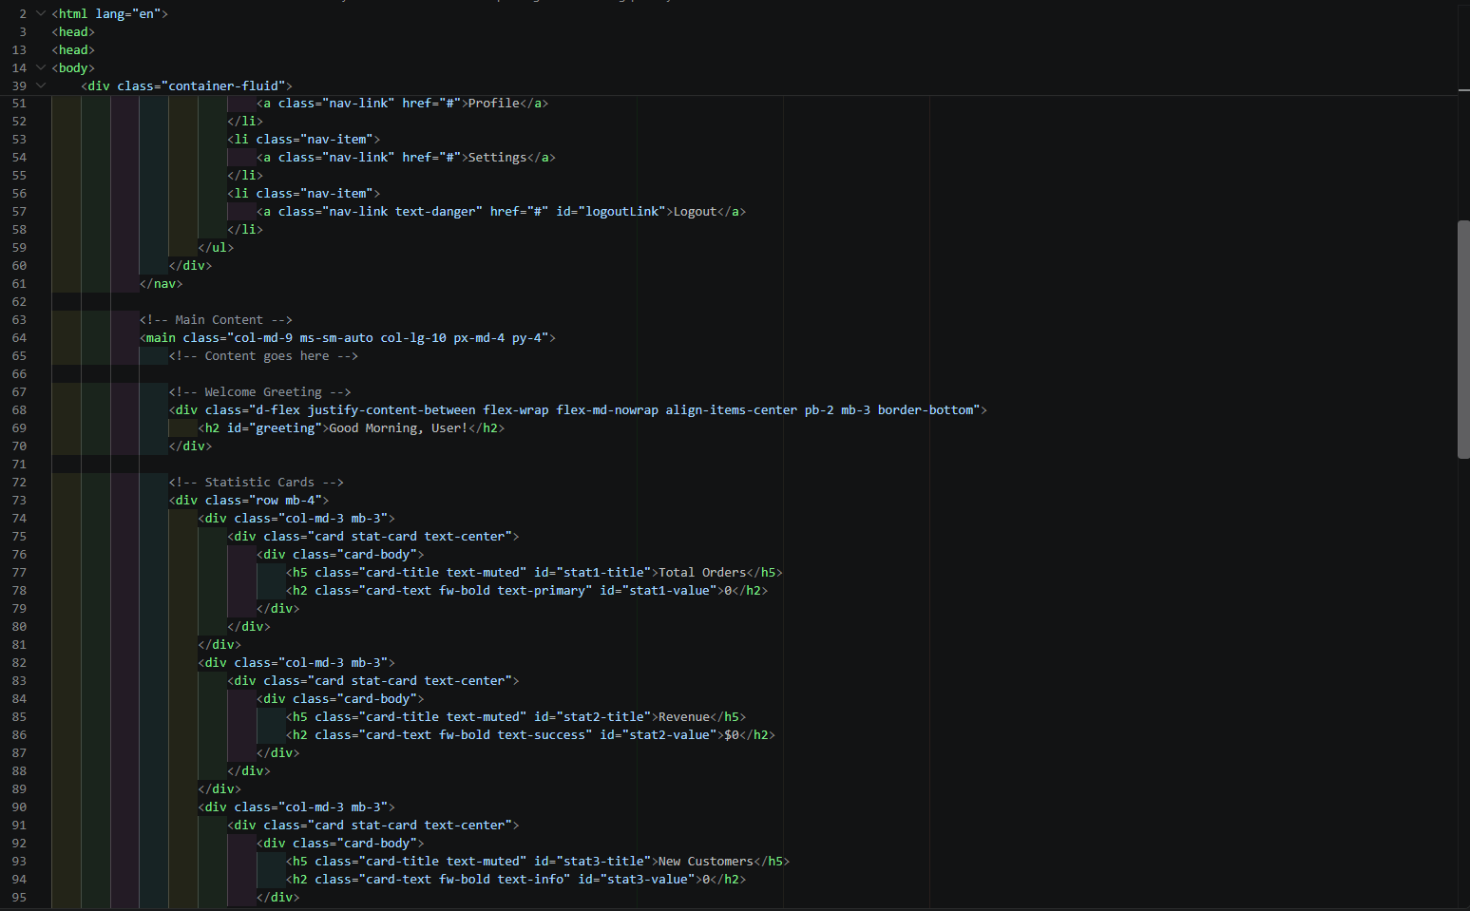
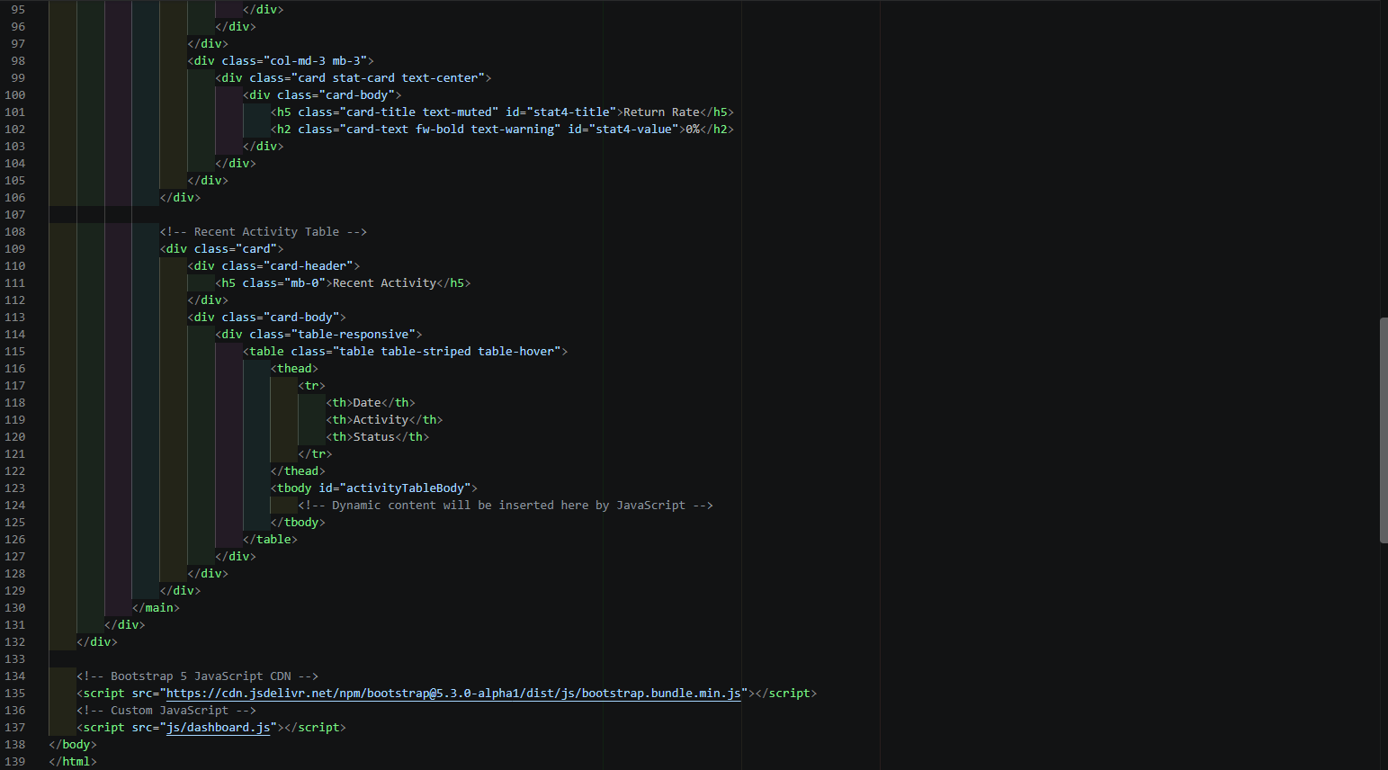

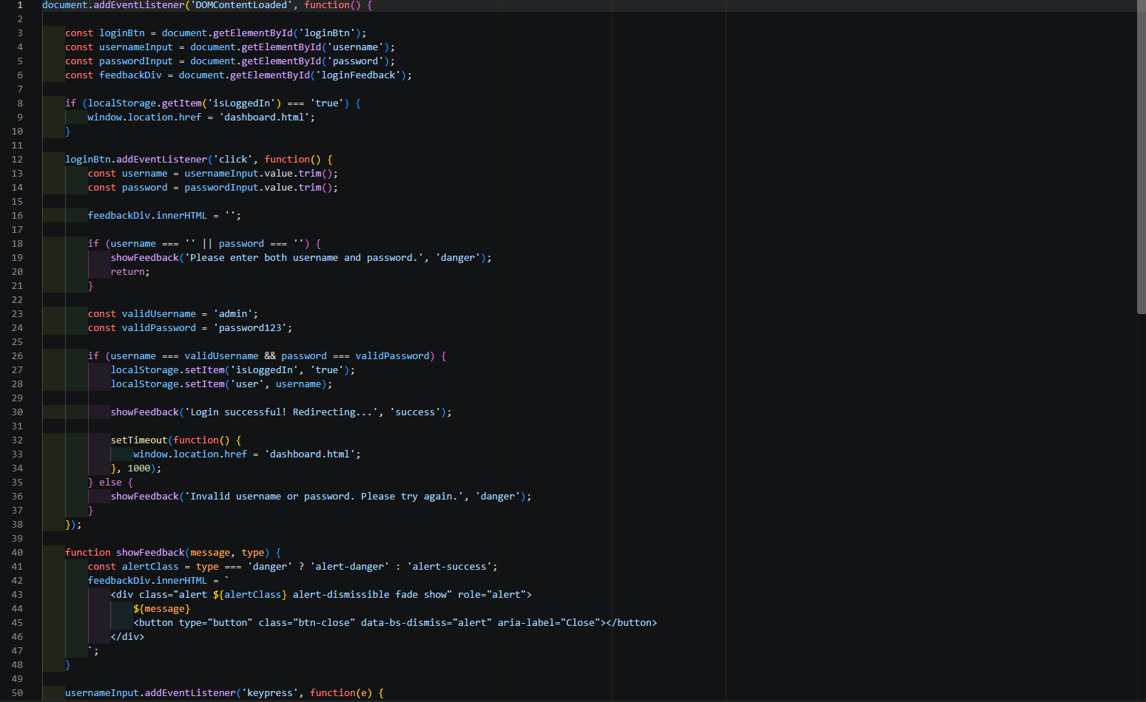
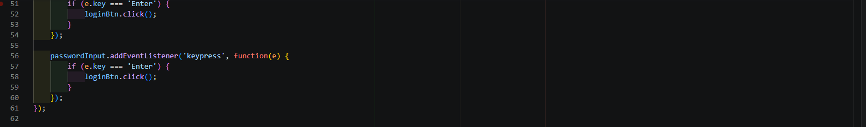

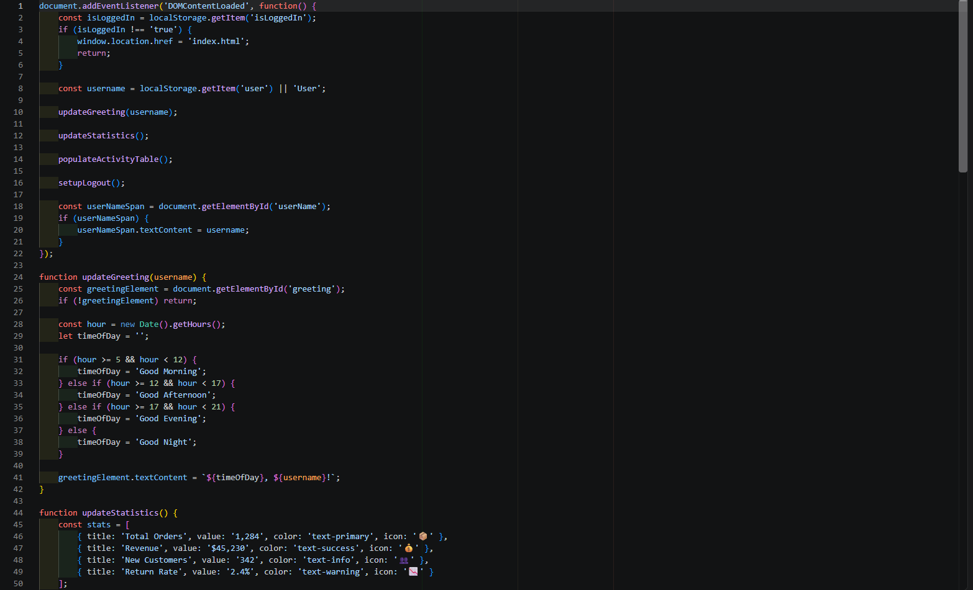
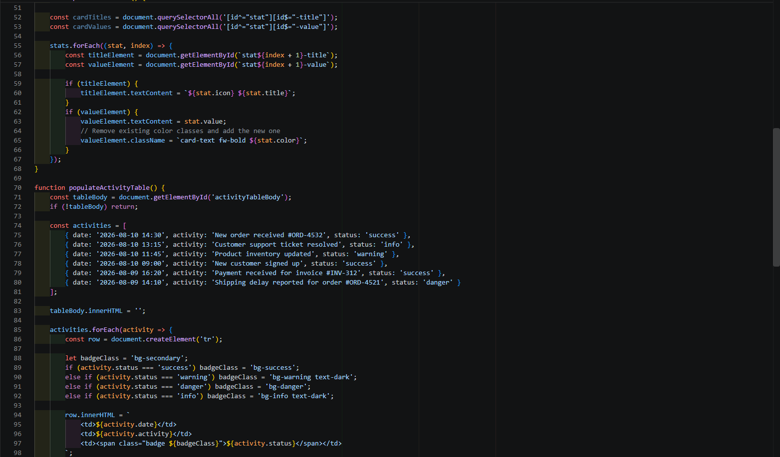

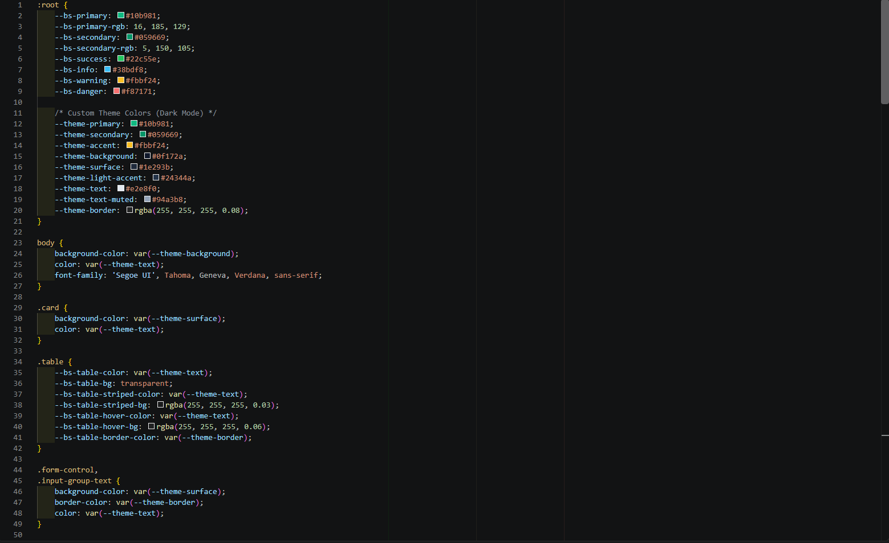
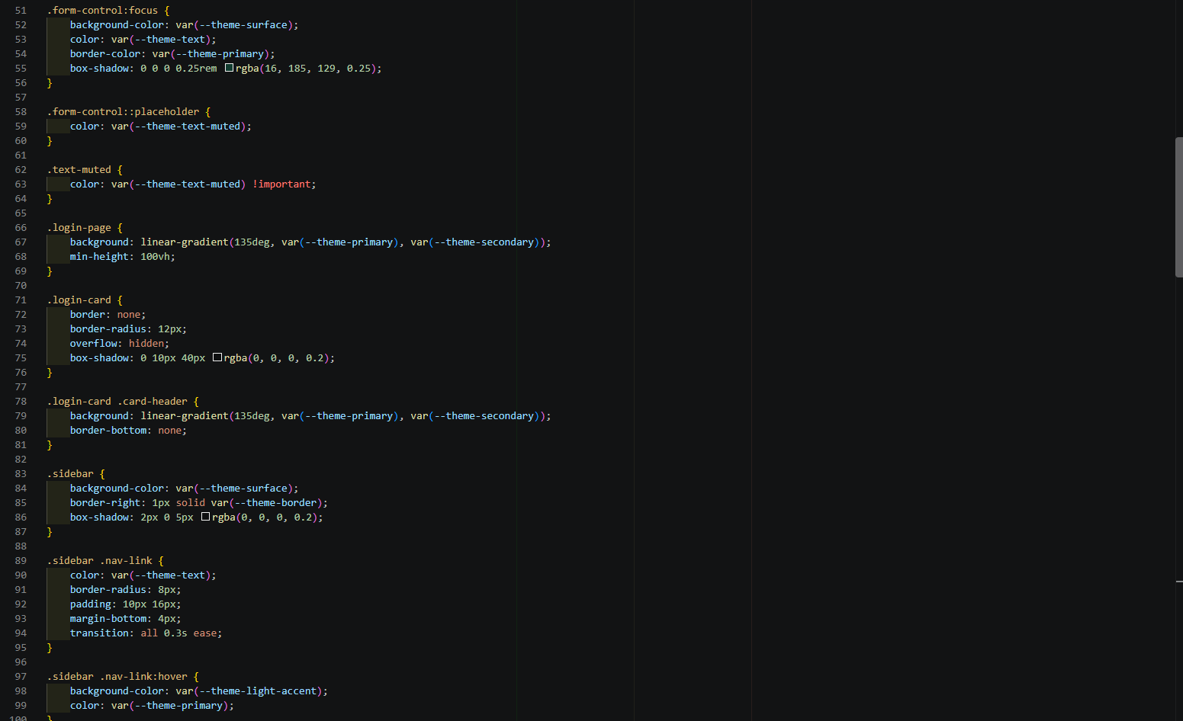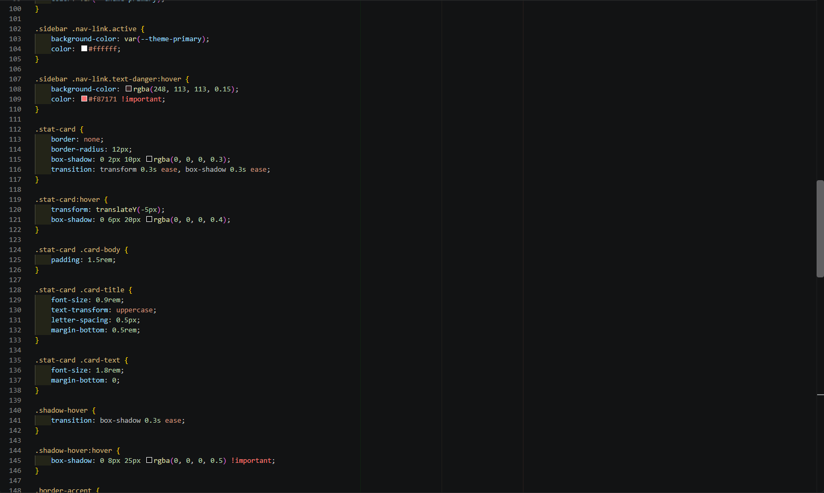
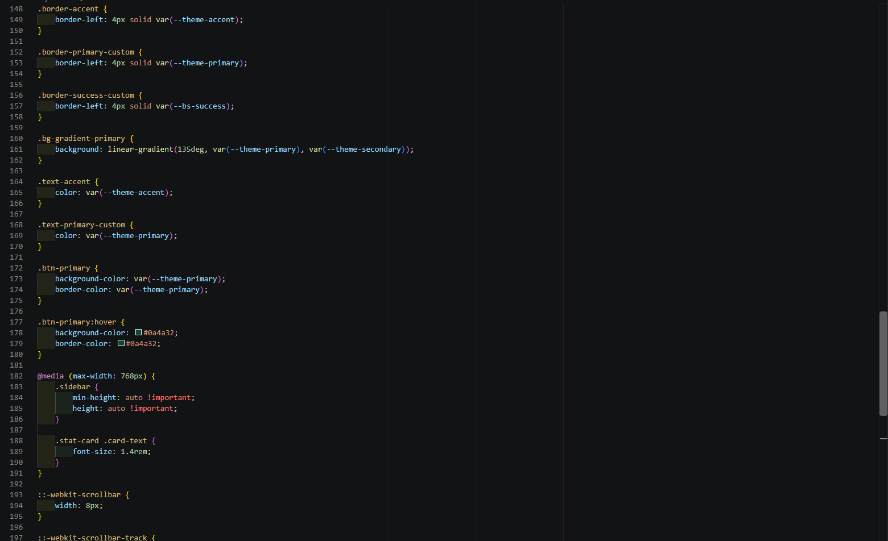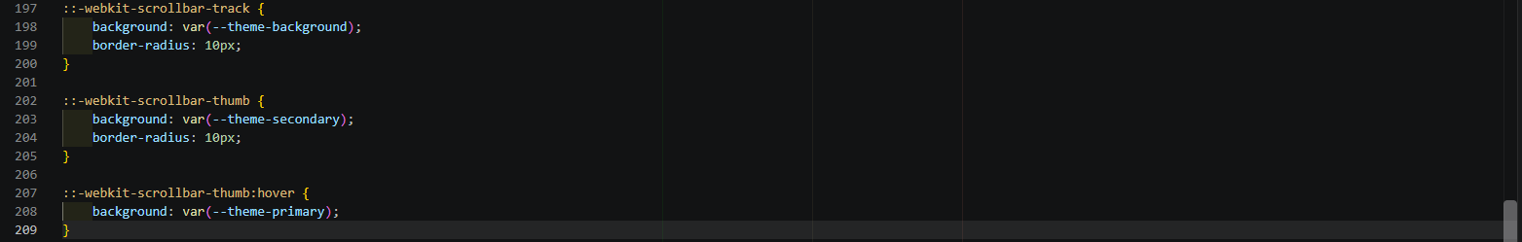
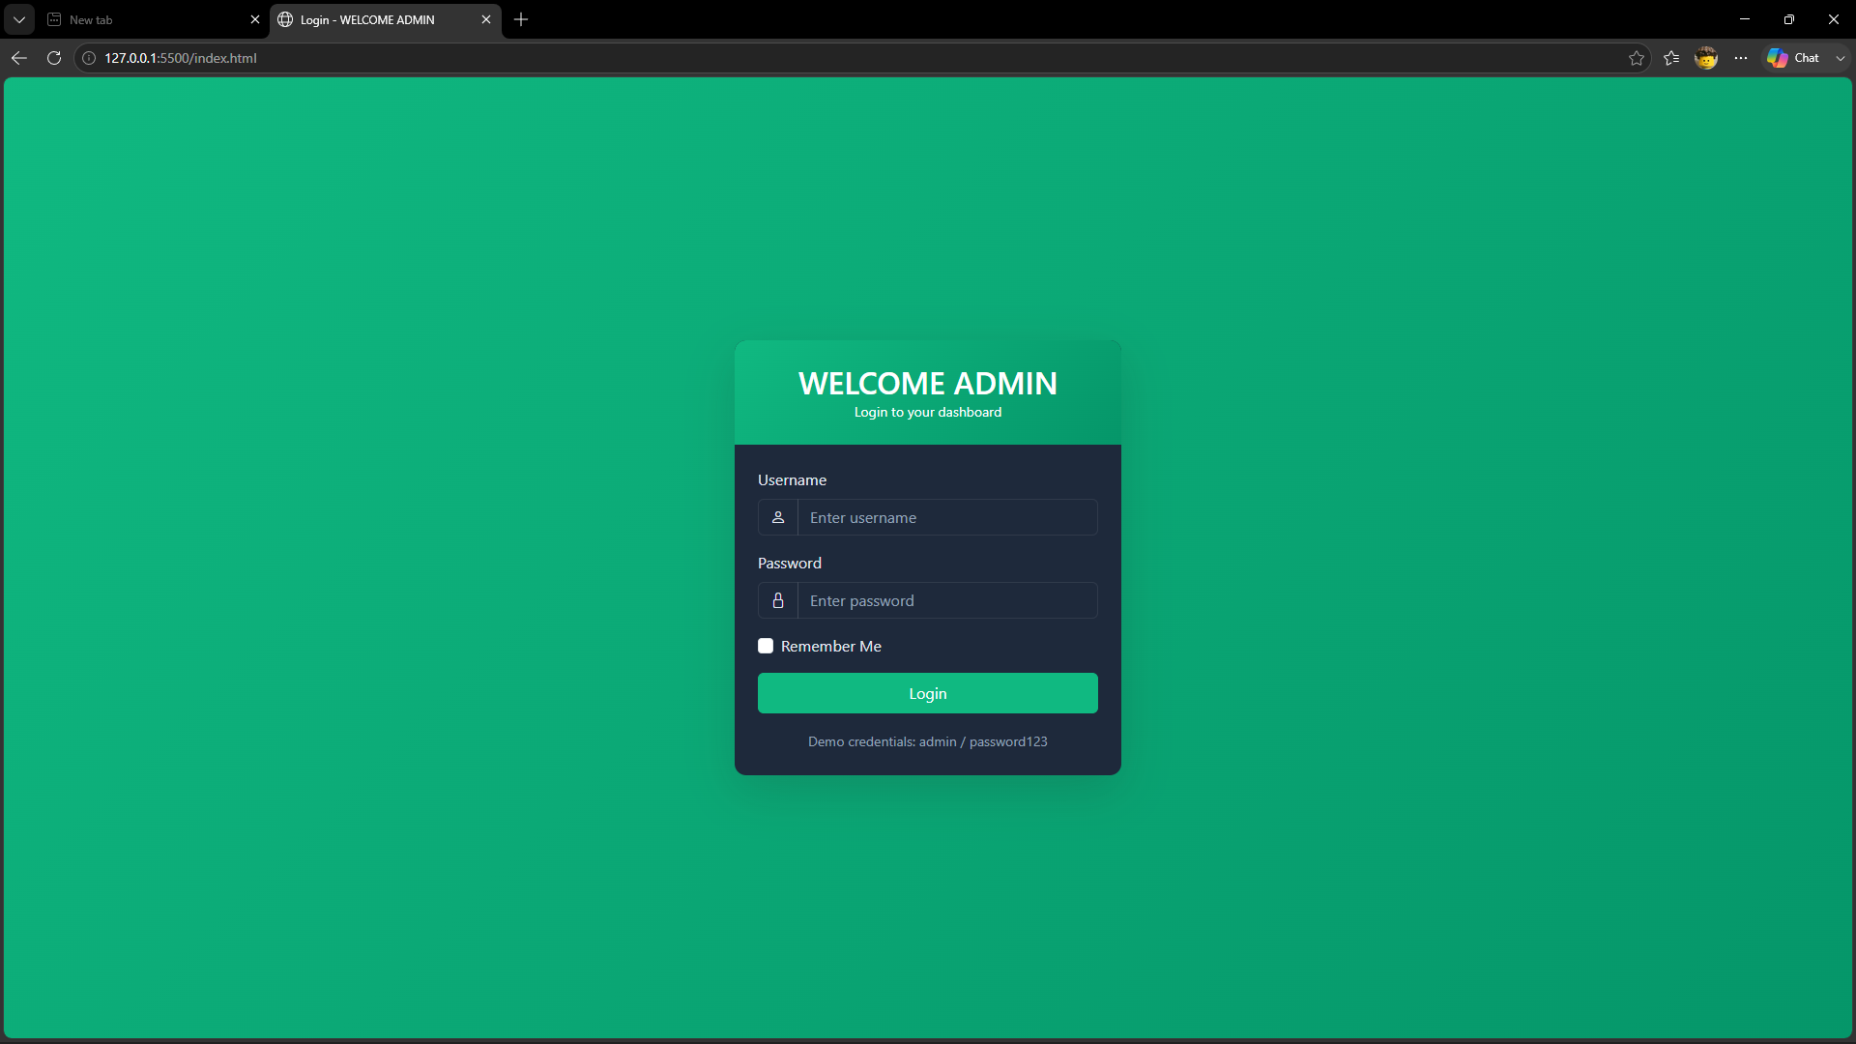

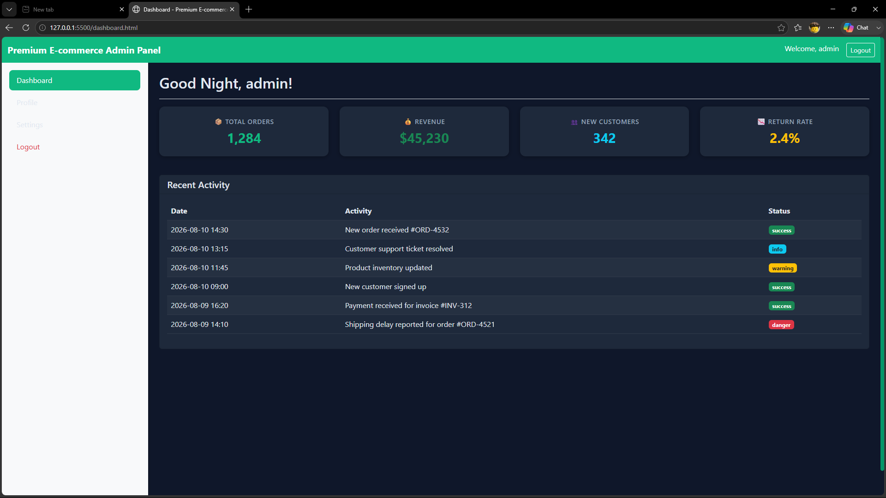

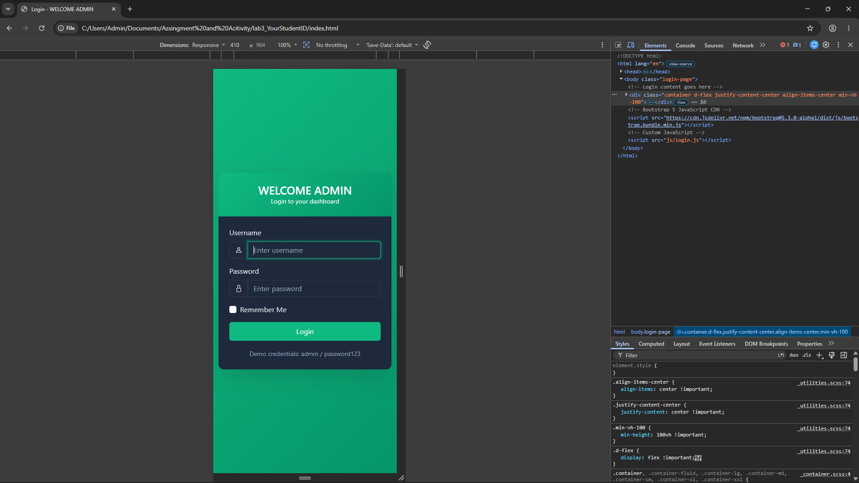
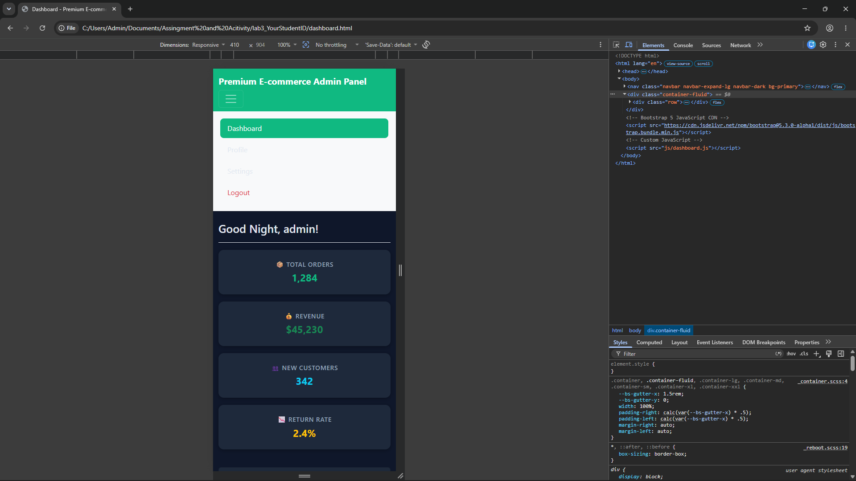

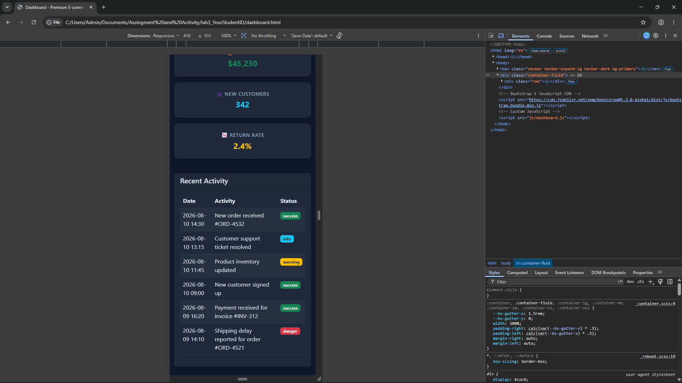
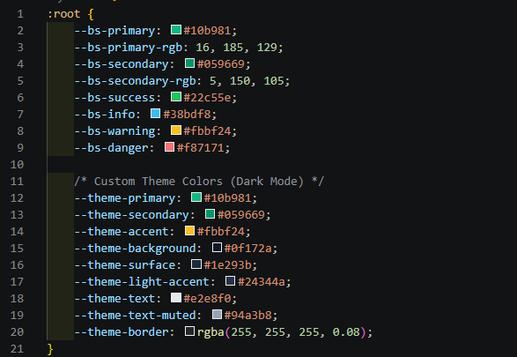
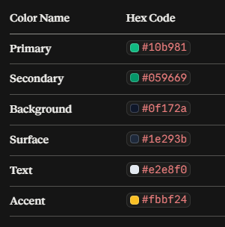

Conclusion
This assignment involves creating a responsive web application with two pages, a login page (index.html) and a dashboard (dashboard.html) that is based on a particular business idea in a clean manner in a project folder with css/, js/ and assets/ subfolders. The application utilizes Bootstrap 5 and custom CSS variables for styling along with localStorage for managing local user authentication and state where login.js does the job of credential validation and dashboard.js implements route protection for redirecting unauthorized access, manipulates dynamic metric cards and tables using JavaScript array and dynamic time-based greetings along with logout functionality. The submission of the lab involves organizing the codebase, deploying it to GitHub and creating a single PDF document Lab3_YourStudentId_YourLastName.pdf which contains nine screenshots (VS Code files, browser desktop/mobile pages, GitHub commits, color palette) along with questionnaires answers and a reflection of lessons learnt.

